Warning – Exhaust Overtemp Protection – CGEA1.3

Functional Description

The purpose of the Exhaust Overtemp Warning feature is to inform the driver of a diesel powertrain fault (causing over temperature condition in the exhaust manifold) that has resulted in the PCM entering "limp home" mode. This warning is displayed on the Message Center display whenever the Exhaust_Overtemp_Chime&MC_Status_Flag = Active.

The Exhaust_Overtemp_Chime&MC_Status_Flag status flag is defined in the Exhaust Overtemp Warning Chime section of this SPSS.

Interface

Interface Context Diagram (I/O Block Diagram)
Figure 1 Warning – Exhaust Overtemp Context Diagram
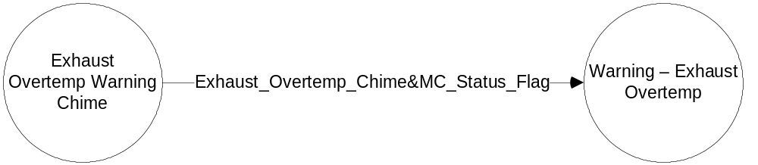

Inputs

- Exhaust_Overtemp_Chime&MC_Status_Flag.
See the Exhaust Overtemp Warning Chime section of this SPSS for definition of the state of this flag.

Outputs
- Warning Message W050.
For definition of W050, see the Text Message List section of this SPSS.

Function/Performance

Operational Description

Warning Message W050 shall be Active whenever Exhaust_Overtemp_Chime&MC_Status_Flag = Active,
and shall be Inactive whenever Exhaust_Overtemp_Chime&MC_Status_Flag ≠ Active.

For definition of how the Message Center arbitrates and displays Active warnings, see the Warning / Alert Display Logic Diagram, located in the Message Center – X Display with W Button Interface section of this SPSS (where X and W are appropriate values in this document).

Table 1 System Check Function for Diesel Limp Home Warning

Exhaust_Overtemp_Chime&MC_Status_Flag | Mc SYSTEM CHECK  Message ID
INACTIVE | Skip to next function
ACTIVE | W050

SPSS Module Revision History

Revision Level | Name | Change Description | Date
1.0 | V. Patel | Updated for CGEA1.3. Based on CGEA Warning - Diesel Exhaust Overtemp STSS V1.0  No updates required for CGEA1.3 | 5/11/2010

